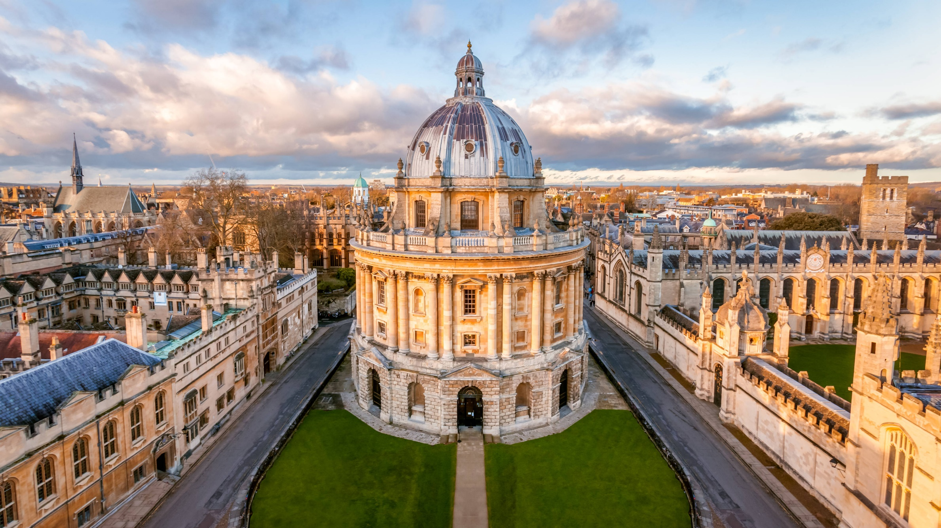

|  |  |
| --- | --- |
| **The Rhodes Scholarship fully covers two years of study and most of the graduate’s expenses in Oxford, including:**   * Oxford University tuition fees, * An annual stipend (to cover accommodation fees and living expenses), * One return air flight (SA-UK-SA) per scholarship, * Financial assistance with Student Visa and health insurance costs for the duration of the scholarship, * A settling in allowance and * Superb wrap-around support and an in-house Character, Service and Leadership Programme   The Trust does not provide financial assistance for undergraduate degrees; or to postgraduate students who are studying at other universities in the UK or elsewhere; or to students who have not gone through the formal selection process for the Rhodes Scholarships in Southern Africa  **Who is eligible to apply?**   * Citizen and resident of South Africa; * Under the age of 33 years old on 1st January 2023; * Applicants must be eligible for admission to the chosen Master’s or Doctoral programme; * <https://www.rhodeshouse.ox.ac.uk/scholarships/applications/southern-africa/eligibilitycriteria/> | **Application process**    Applications for the Rhodes Scholarships can only be submitted using the online application system at <https://www.rhodeshouse.ox.ac.uk/scholarships/applications/> Applicants MUST submit the following documents with the application:   * A copy of your birth certificate, a valid passport or ID document. * An official transcript from the college or university showing grades achieved (to date). * A copy of your South African National Senior Certificate (NSC) and Copies of your degree certificates. * Details of any employment or enterprise you have undertaken during your studies or thereafter. * A detailed CV with all achievements This should not exceed two A4 (12pt font size) pages in length. * A head-and-shoulders colour photograph (jpg format). * A personal statement of no more than 1,000 words.   Candidates are strongly encouraged to read the general information on the <https://www.rhodeshouse.ox.ac.uk/scholarships/the-rhodes-scholarship/>, the Conditions of Tenure for the Rhodes Scholarship and the graduate admissions pages of the University of Oxford: <https://www.ox.ac.uk/admissions/graduate> before applying. |
| **Programmes available:**   |  |  |  | | --- | --- | --- | | **Programme name** | **University** | **Application website** | | PhD in Biology (Plant Science and Zoology) | Oxford University | <https://www.ox.ac.uk/admissions/graduate/courses/dphil-biology> | | MSc in Sustainability, Enterprise and the Environment | Oxford University | <https://www.ox.ac.uk/admissions/graduate/courses/msc-sustainability-enterprise-environment> | | MSc in Environmental Change and Management | Oxford University | <https://www.ox.ac.uk/admissions/graduate/courses/mphil-environmental-change-and-management> | | **Closing date:**  *Applications for 2023 open on* ***01 June 2022 and close on 01 August 2022****.* **All documents should reach Ms Jacky Smit and Mr Sello Tlhatlha before or on the closing date***.*  ***Note:*** *All applicants should first apply to Oxford University and get an admission before applying to the Rhodes Scholarships, kindly visit The Rhodes Scholarship:* [*https://www.rhodeshouse.ox.ac.uk/scholarships/the-rhodes-scholarship/*](https://www.rhodeshouse.ox.ac.uk/scholarships/the-rhodes-scholarship/) *follow the instructions as per the attached application instruction guideline document.* | | | | | |

The United Kingdom (UK) is inviting applications from South Africans who wish to pursue Master’s or Doctoral studies to apply for the Rhodes Scholarships. This Scholarship is the oldest global scholarships programme in the world, are for post-graduate, full-time studies at Oxford University in the UK. Online applications are invited from outstanding young graduates who excel academically; demonstrate leadership skills and are committed to making a difference in the broader community, both locally and internationally. Annually 10 (ten) Rhodes Scholarships are awarded to graduates in the Southern African constituency (comprising South Africa, Botswana, Lesotho, Malawi, Namibia and eSwatini), wishing to pursue Masters or Doctoral studies at Oxford University in most disciplines/fields of study. For detailed information on selection criteria and the region/selection committee to which you should apply.

|  |  |
| --- | --- |
| **Enquiries and submission of application forms:**  Mr Sello Tlhatlha  **Tel:** 012 919 7159  **Email:** [**SelloTlh@dalrrd.gov.za**](mailto:SelloTlh@dalrrd.gov.za) | **For Further Enquiries:**  Ms Jacky Smit  **Tel:** 012 319 7019  **Email:** [**JackyS@Dalrrd.gov.za**](mailto:JackyS@Dalrrd.gov.za) |







The Rhodes Scholarships for Southern Africa 2023



